**Ideation Phase**

**Define the Problem Statements**

|  |  |
| --- | --- |
| Date | 31 May 2025 |
| Team ID | LTVIP2025TMID43861 |
| Project Name | Transfer Learning-Based Classification of Poultry Diseases for Enhanced Health Management |
| Maximum Marks | 2 Marks |

**Customer Problem Statement Template:**

Understanding the challenges faced by poultry farmers is key to designing an effective disease detection system. This problem statement framework helps us empathize with farmers and develop AI-powered solutions that are not only accurate but also accessible and easy to use.

By clearly identifying the farmer’s pain points, we can create a mobile-based poultry disease classifier that meets their real-world needs, improves livestock health, and prevents economic losses.

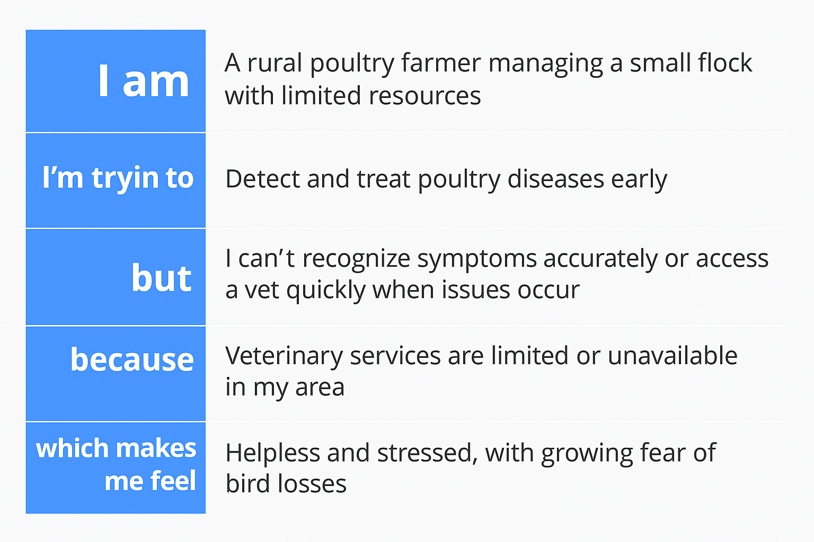

Reference: <https://miro.com/templates/customer-problem-statement/>

**Example:**

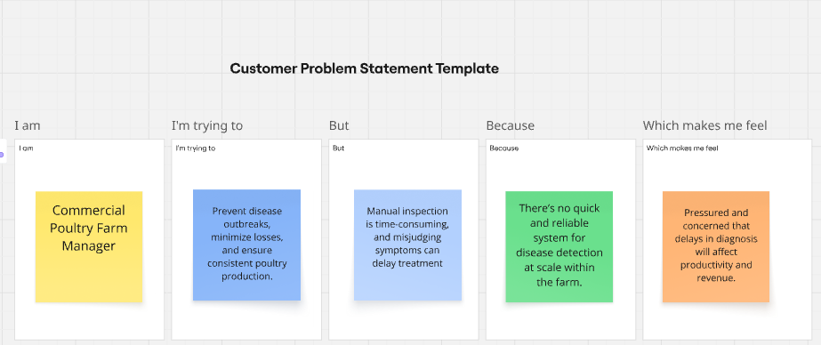

|  |  |  |  |  |  |
| --- | --- | --- | --- | --- | --- |
| **Problem Statement (PS)** | **I am (Customer)** | **I’m trying to** | **But** | **Because** | **Which makes me feel** |
| PS-1:  Rural Poultry Farmer | A rural poultry farmer managing a small flock with limited resources and no formal veterinary support. | Identify diseases in my birds early and take the right action to protect their health and avoid financial losses. | I can’t recognize the symptoms accurately and there’s no easy way to confirm what disease is affecting them. | I don’t have access to trained vets or affordable diagnostic tools. | Stressed and worried, fearing I’ll lose birds and income without timely help. |
| PS-2:  Commercial Poultry Farm Manager | A commercial poultry farm manager responsible for monitoring the health of hundreds of birds. | Prevent disease outbreaks, minimize losses, and ensure consistent poultry production.  . | Manual inspection is time-consuming, and misjudging symptoms can delay treatment. | There’s no quick and reliable system for disease detection at scale within the farm. | Pressured and concerned that delays in diagnosis will affect productivity and revenue. |